Here is the graph of N over iterations:

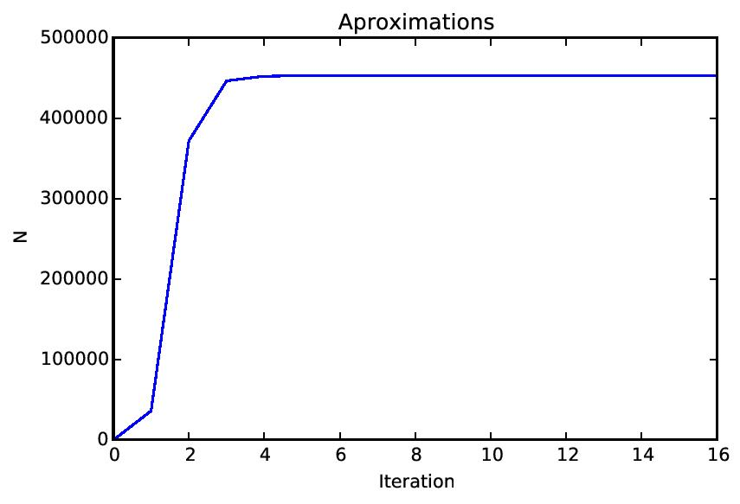
And here is the “drawing”. It was made using Google's “Deep Dream Generator”. You should look at it in color.

